I/We would like to support The National Trust Clayton Wesley Conservation Appeal  by making a fully tax deductible donation.  Mr Mrs Ms Miss Dr Rev  Name(s) ...........................................................  Address ...........................................................  …………………………………………………………….  State ................... Postcode ………..............  Email ….............................................................  Phone ...........................................................  Mobile ...........................................................  I/We would like to donate the sum of  $50 $100 $500 O $1000 Other $ ........  or  Please deduct $ .......... each month from my credit card until I advise otherwise  or  I Would like to donate $ .......... now and for each of the next four years.  (A reminder will be sent to you each May.)  Method of payment:  By cheque made out to The National Trust Clayton Wesley Conservation Appeal and enclosed;  or  Please charge my credit card:  MasterCard d Visa AMEX  Card no. __ __ __ __ __ __ __ __ __ __ __ __ __ __ __ __  Name on card........................................................  Expiry date ...... / ...... / ...... CVV ............  Signature ..........................................................  I I/we would like my gift to remain anonymous  Please send me information about how I can include the Conservation Fund in my Will.  Please inform me how to donate on-line.  Thank you for your donation. |  | William James Maxwell was a renowned sculptor in his native Scotland and England before emigrating. He worked in Adelaide, Melbourne and Sydney. His statue of Robert Burns is at the State Library. These photographs of the carving on the tower show the importance of having this conservation work done.  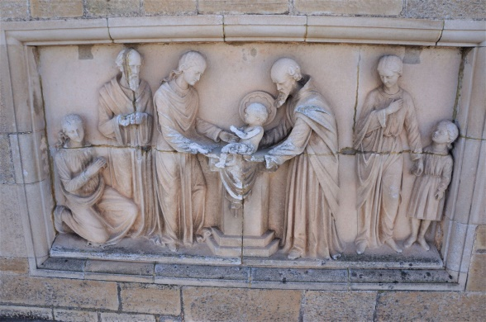  The relief before restoration  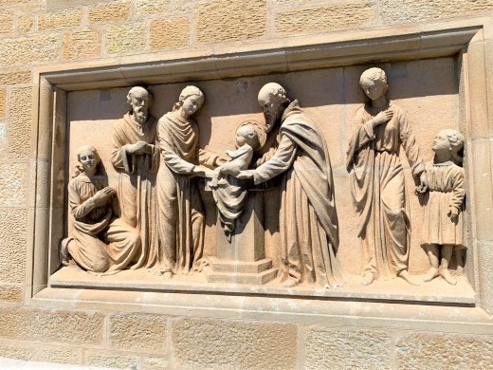  Following the restoration work  Please complete the donation form and mail it to:  The National Trust Clayton Wesley Conservation Appeal  Beaumont House  631 Glynburn Rd, Beaumont SA 5066  Thank you for your donation. |  | 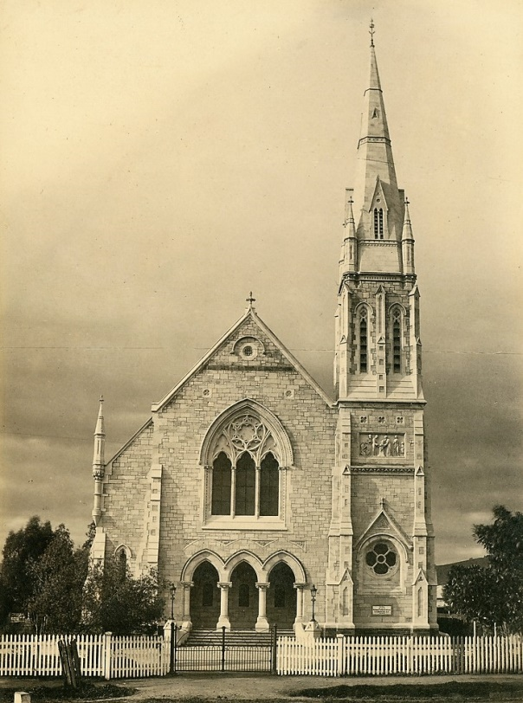  Clayton Congregational Church, c. 1897  The National Trust  Clayton Wesley  Conservation Appeal  Our next project  The glass in the main west window of the church, which faces down The Parade, will be restored and replaced. Over nearly 100 years of exposure to the weather, the glass is loose in its lead supports and some pieces are missing.

